CS 255 System Design Document – Ricky Buchanan

UML Diagrams

UML Use Case Diagram
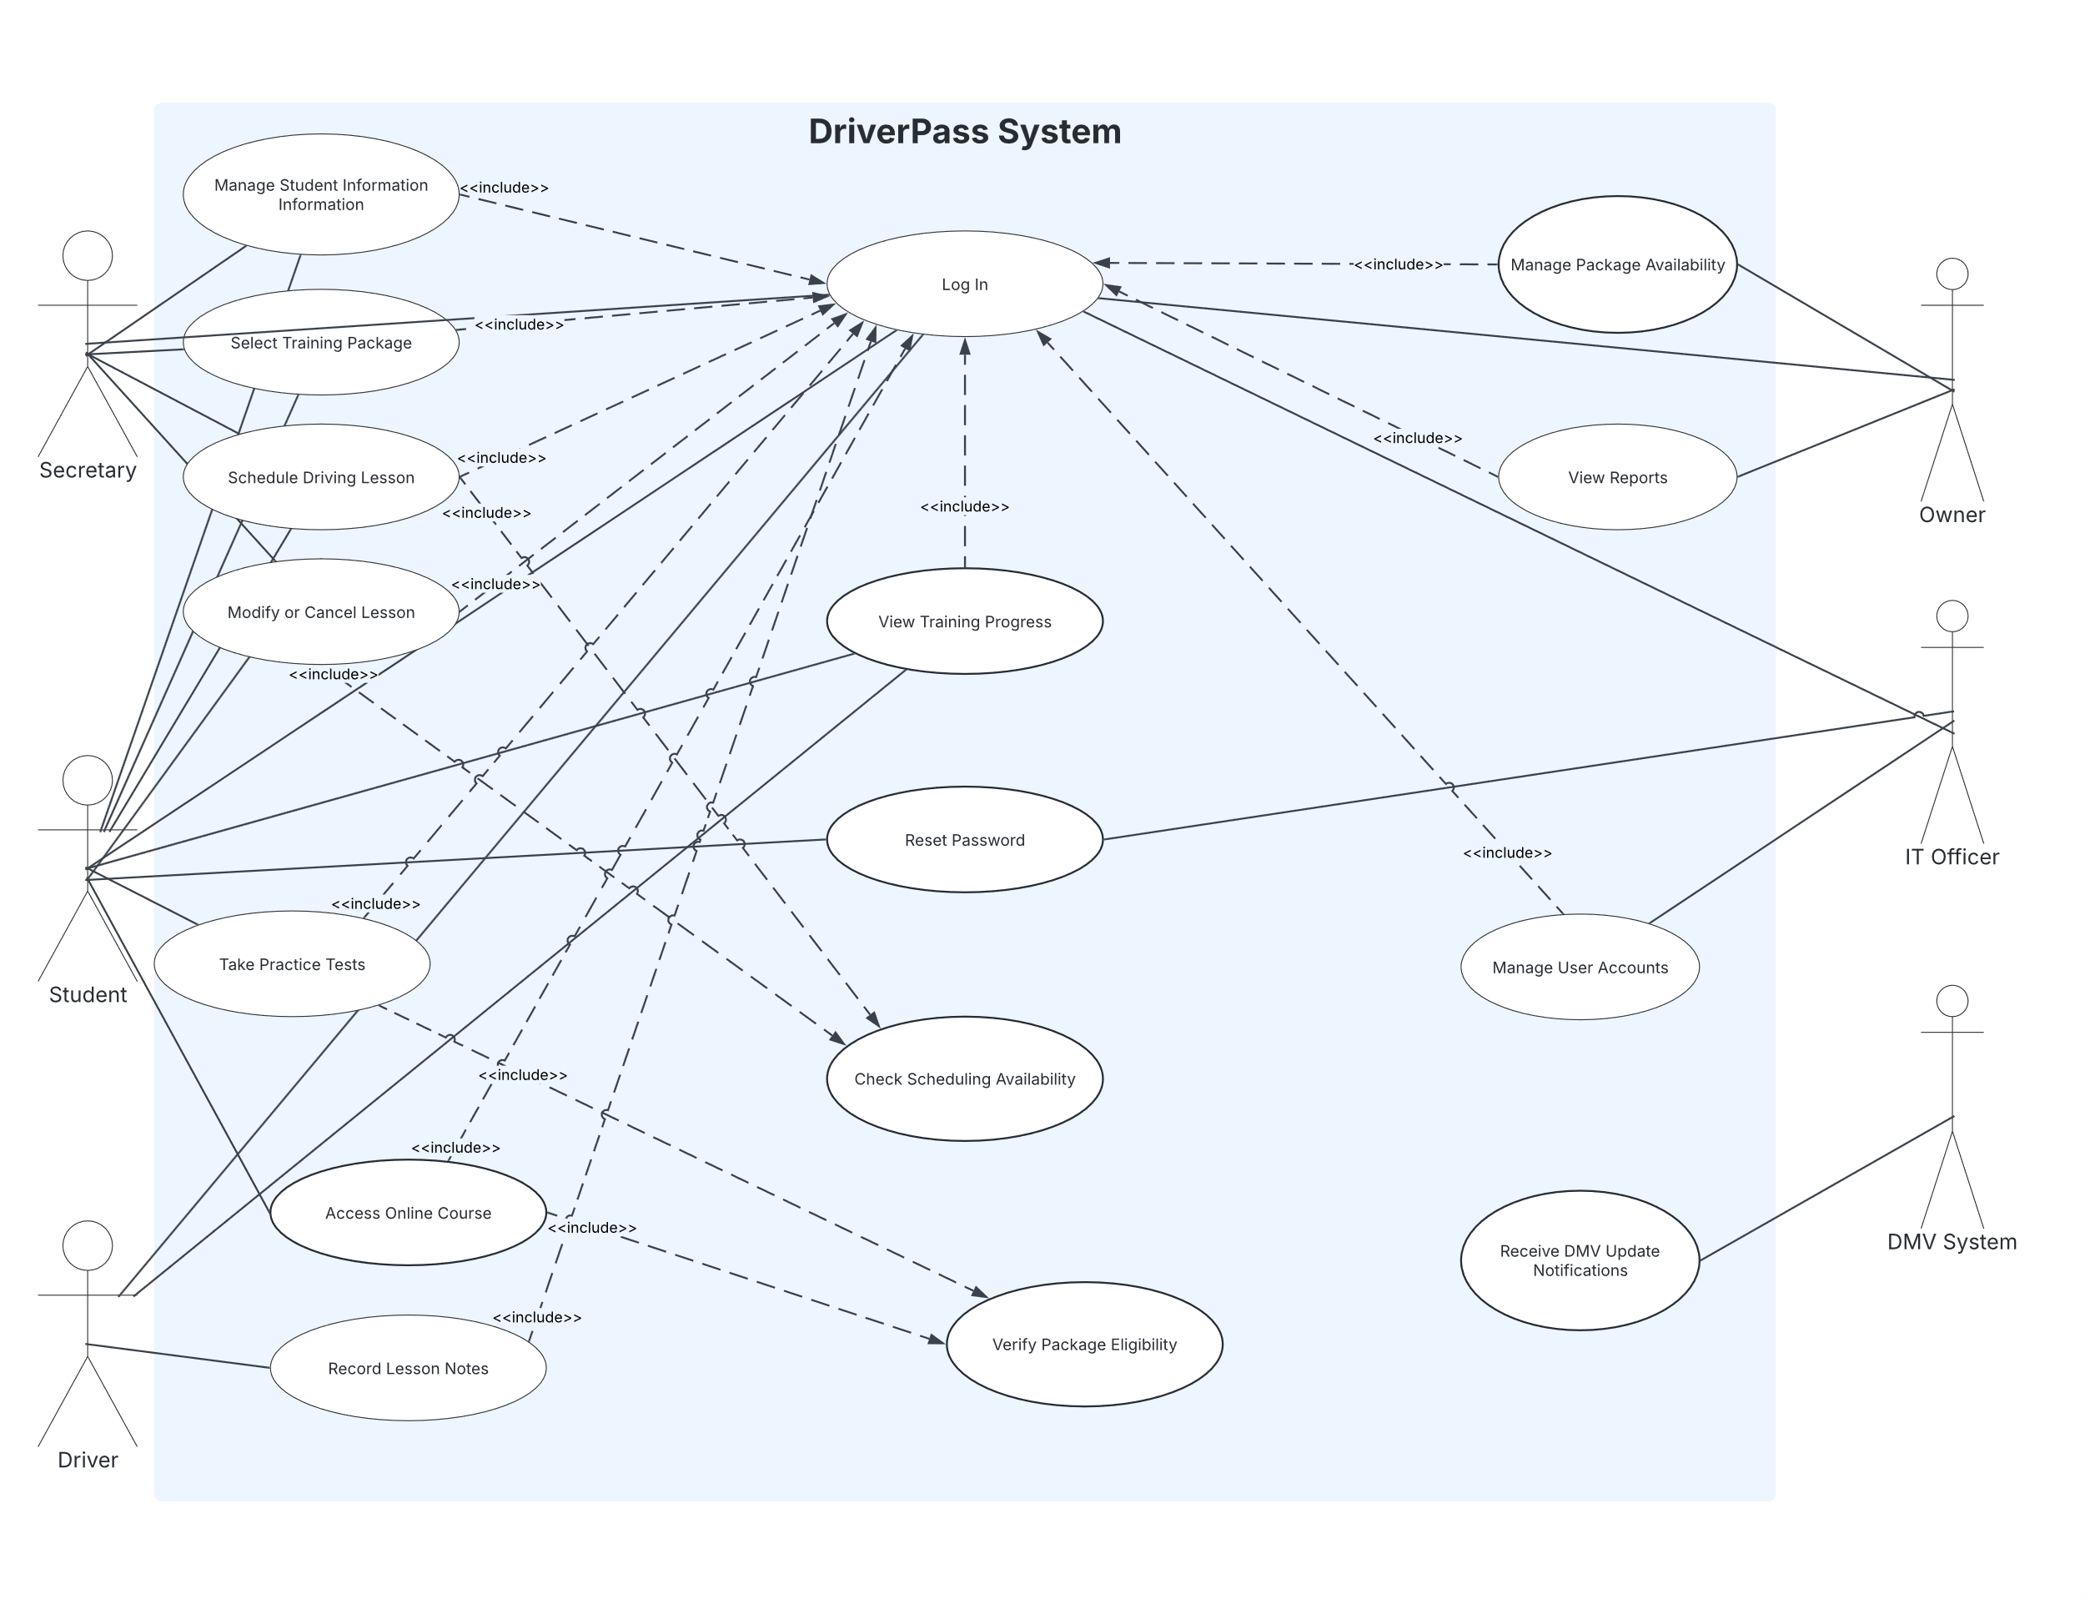

UML Activity Diagrams

Schedule Driving Lesson
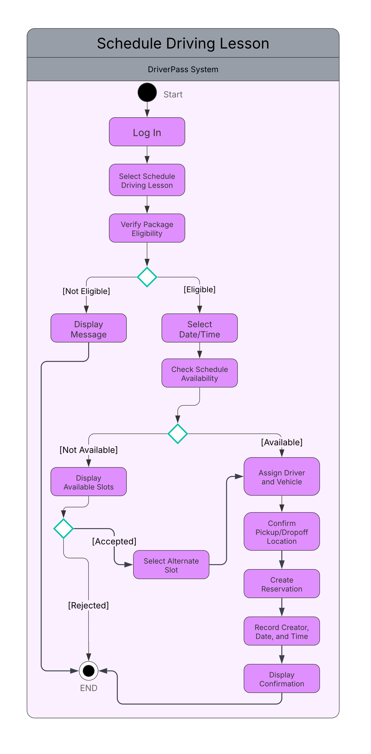

Take Practice Test
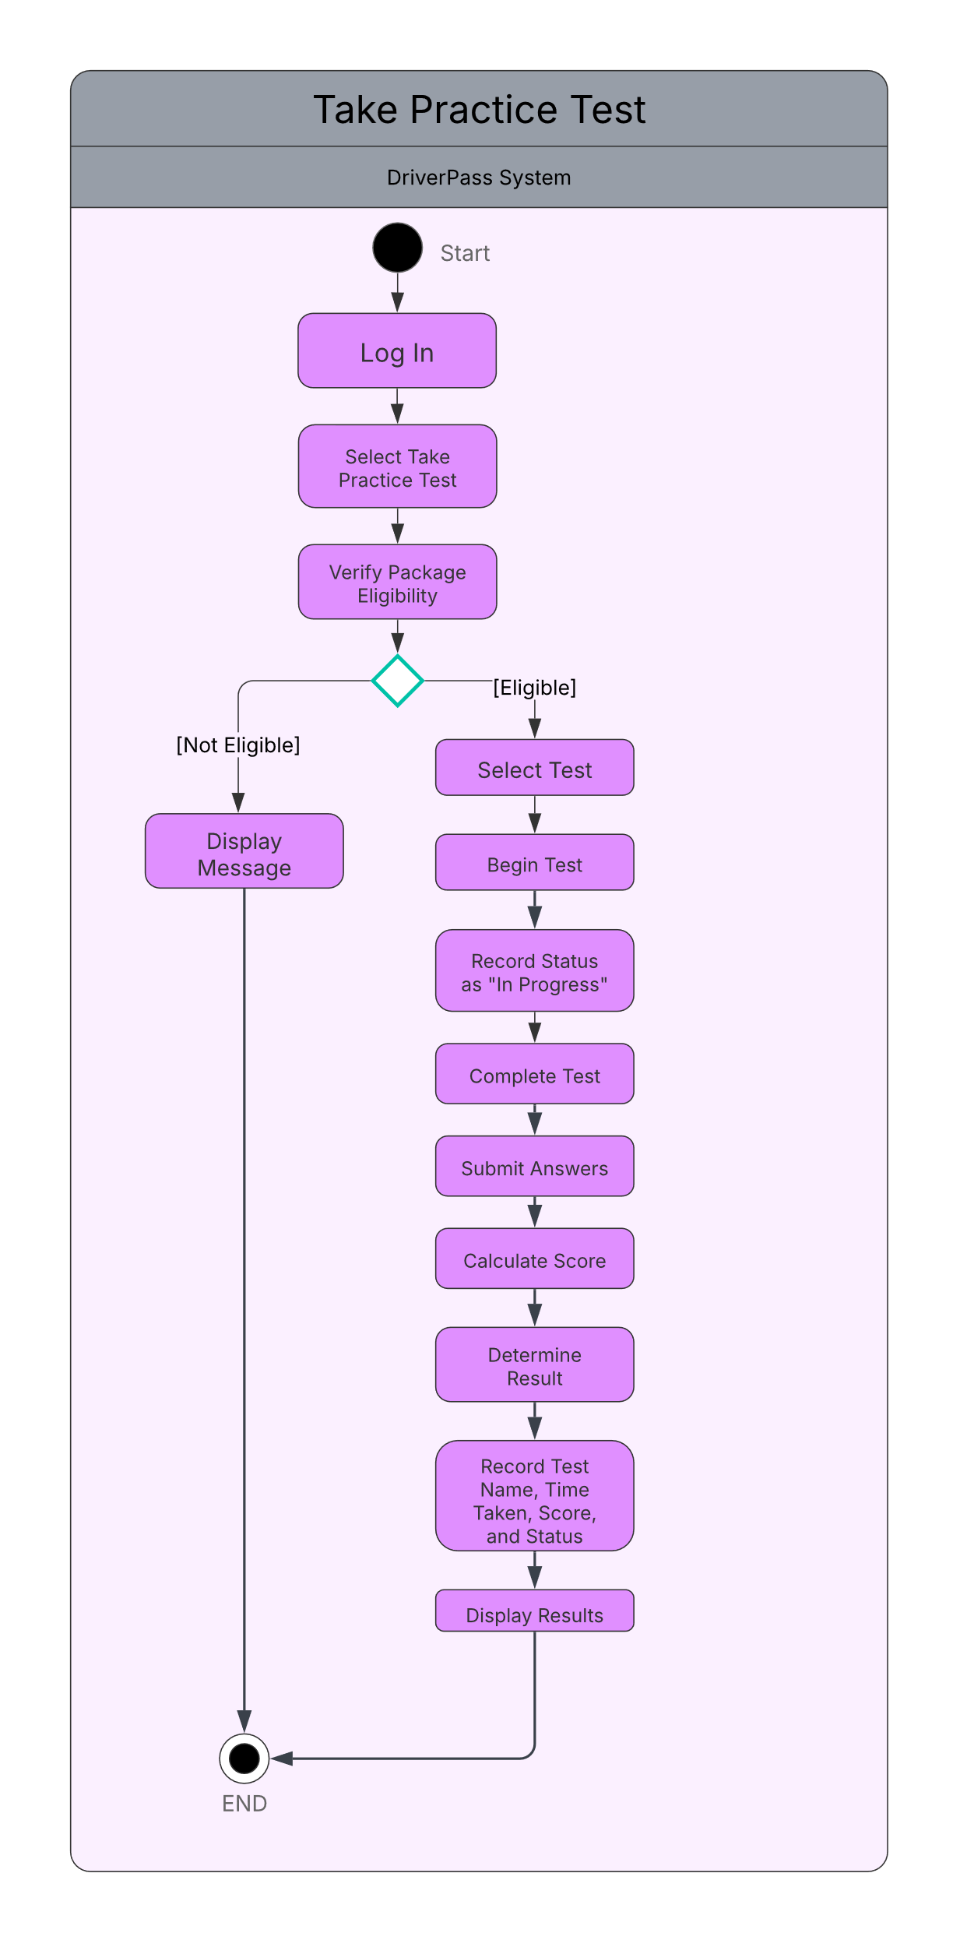

UML Sequence Diagram
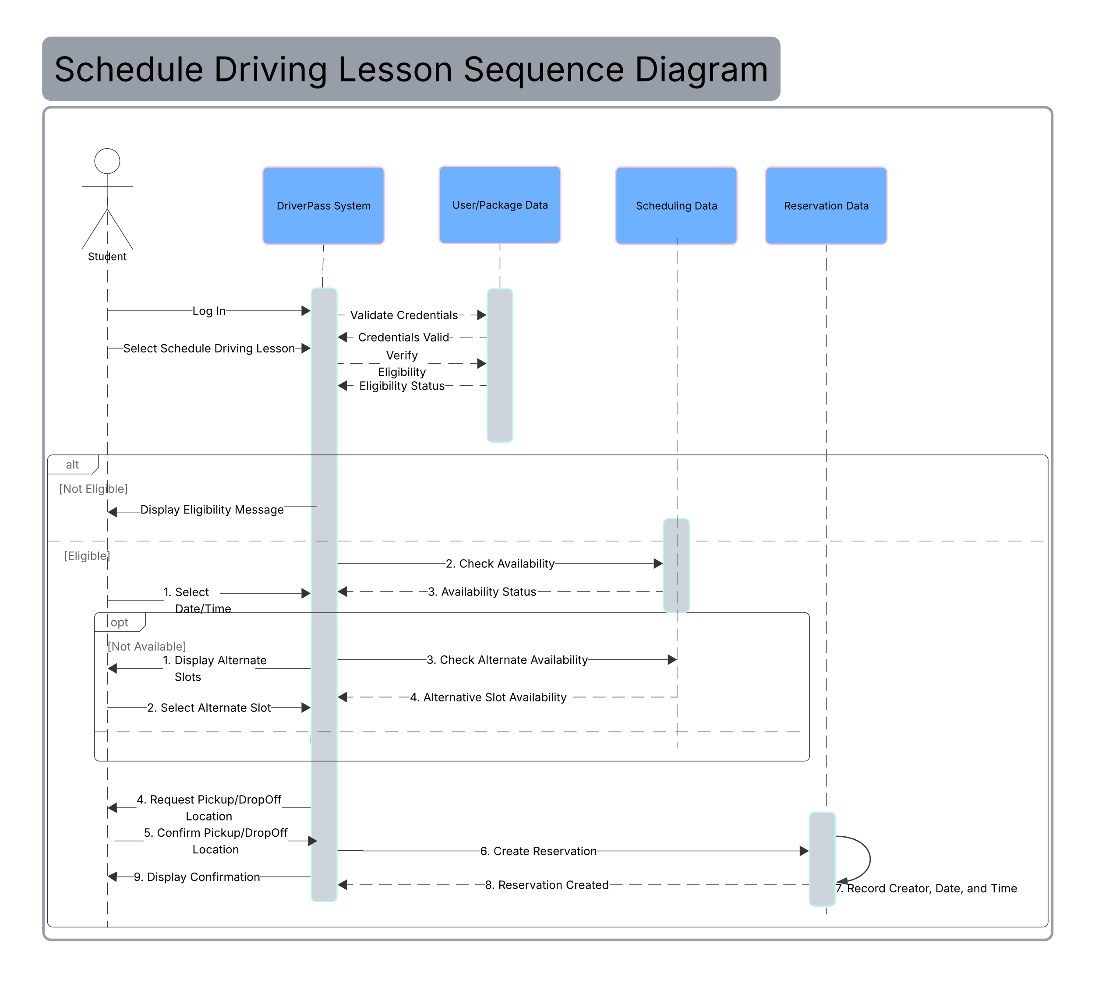
UML Class Diagram
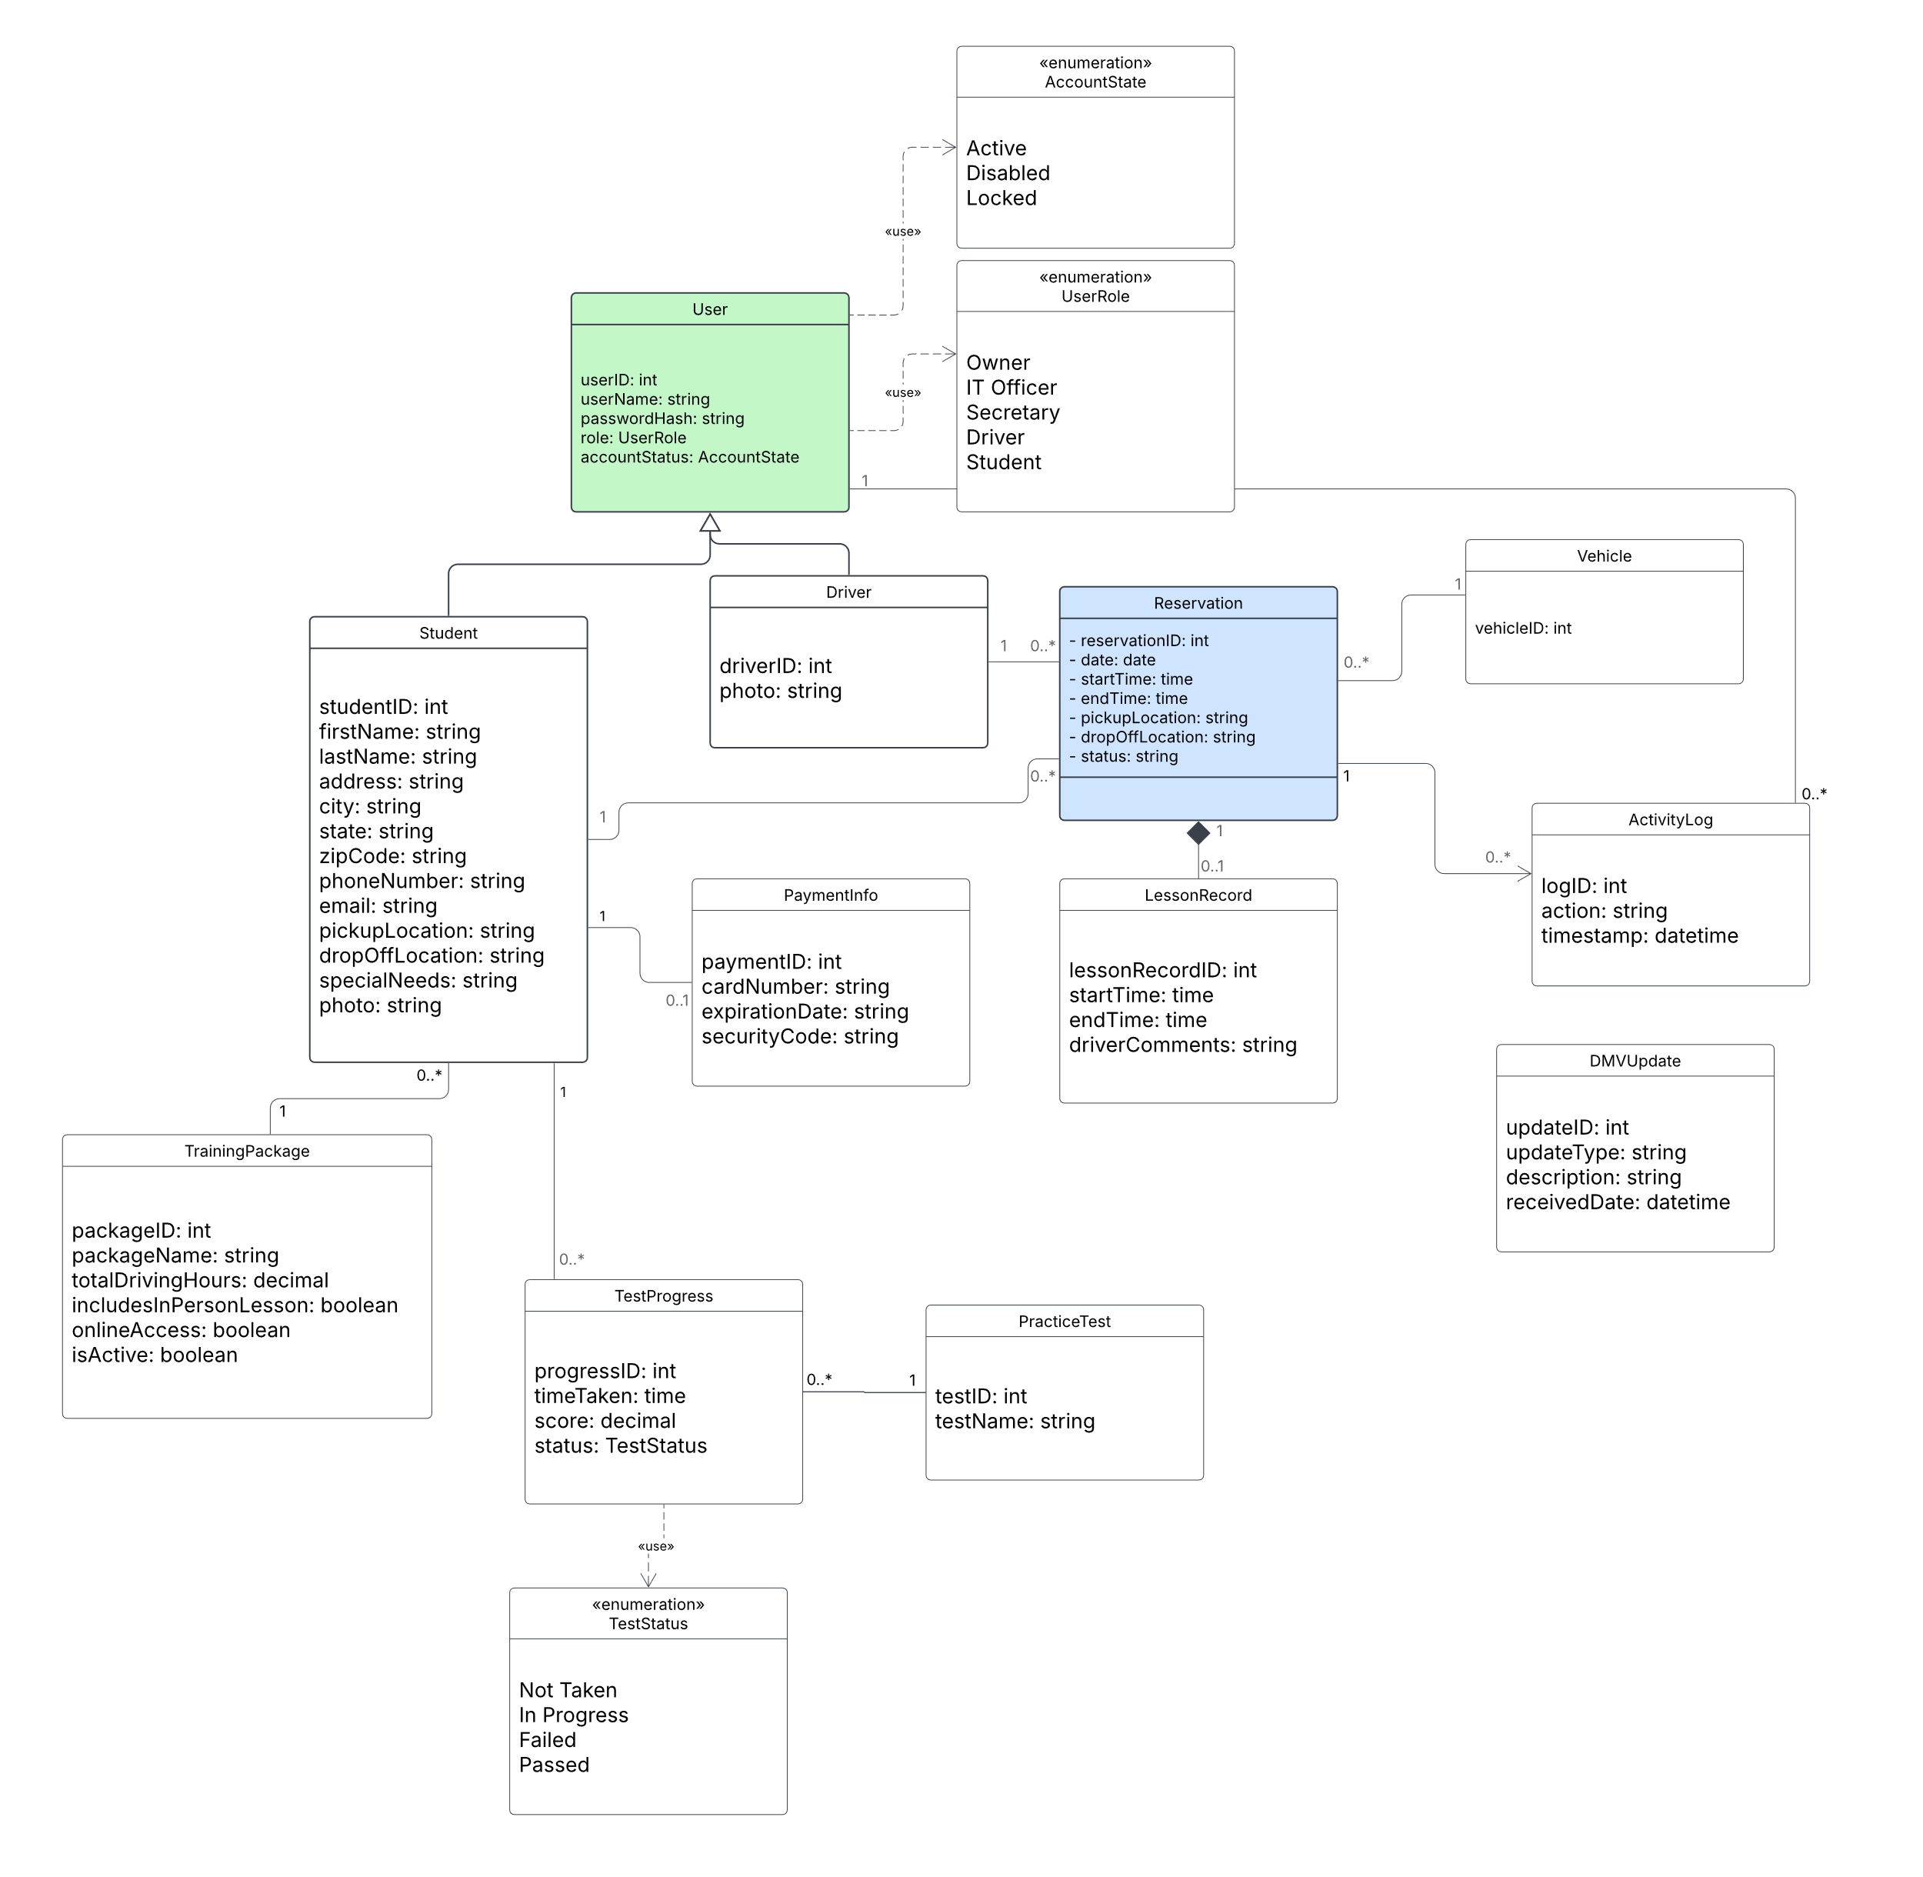

Technical Requirements

The DriverPass system needs a cloud-based environment that hosts a central web application and database. The cloud provider will handle server infrastructure, data storage, backups, and security services. Since DriverPass requested a cloud solution, there is no need for local application servers or dedicated backup hardware. Users will access the system through supported mobile and desktop web browsers with an internet connection.
The software will include a web-based user interface, server-side application, and a central database. This database will store user accounts, student details, training packages, reservations, vehicles, driver assignments, lesson records, practice-test progress, payments, activity logs, and other data identified in the system design. Role-based access and authentication will allow students, drivers, the secretary, the owner, and the IT officer to access functions and information relevant to their duties securely. Authorized users can also generate, print, and download reports for use in applications such as Microsoft Excel. However, changes made to downloaded copies will not synchronize back to the DriverPass system.
Security will protect account data, student records, schedules, training information, and payment details. All communication between the user's browser and the cloud system must be encrypted. Users will authenticate with unique usernames and passwords, with role-based access permissions. After five failed login attempts, the system will temporarily lock the account and notify the IT officer. Students can reset passwords automatically, while the IT officer can reset, disable, or restore employee accounts. Activity logs will record who created, modified, or canceled reservations and when.
A reliable internet connection is essential because users cannot create, modify, or cancel live records offline. Downloaded reports can be reviewed offline, but offline changes will not synchronize with the central system. The infrastructure must also support communication with the DMV to receive updates on rules, policies, or sample questions. Because the DMV communicates with DriverPass as an external system rather than a user, it will not need to log in before providing updates. A payment-processing service must be selected before payment-card information can be used to complete transactions. Since the cloud provider, database, DMV interface, and payment service are not specified, these remain implementation choices rather than fixed requirements.

